**Department of Mining**

**Faculty of Earth Sciences**

**University of Badji Mokhtar**

**- Annaba –**

**Module: English Language Level: First Year (L1)**

**Lesson 03: Prepositions 2024 / 2025**

**Teacher: Bouchemella Ines**

Prepositions

**Definition:**

A **preposition** is a word used to link a noun, pronoun, or phrase (the object of the preposition) to other words within a sentence. It often shows a relationship of **time**, **place**, **direction**, **cause**, **manner**, or **possession** between its object and another element in the sentence.

**Types of prepositions:**

1. **Preposition of time:**

Prepositions of time are used to indicate **when** something happens. The most common prepositions of time are **at**, **on**, and **in**. Each is used in specific contexts.

**At**

* Refers to a specific point in time.

**Examples:**

* **At 6 PM**
* **At midnight**
* **At sunrise**
* **At the weekend** *(British English)*

**Key Notes:**

* Used for specific times: *The train arrives* ***at 8:30 AM****.*
* Specific holidays: *We met* ***at Christmas****.*

**On**

* Refers to specific days, dates, or parts of particular days.

**Examples:**

* **On Monday**
* **On July 4th**
* **On my birthday**
* **On a summer evening**

**Key Notes:**

* Used with days and dates: *She was born* ***on August 12th****.*
* Also used for holidays with "day": *We met* ***on Christmas Day****.*

**In**

* Refers to longer periods of time.

**Examples:**

* **In the morning**
* **In October**
* **In 2023**
* **In the 21st century**

**Key Notes:**

* Used with parts of the day: *We’ll leave* ***in the afternoon****.*
* Used for months, years, and centuries: *The building was completed* ***in 1995****.*

Other prepositions

• **By:** Refers to a deadline or before a certain point.

* Example: *Finish your homework* ***by 10 PM****.*

• **Since:** Refers to a starting point in the past.

* Example: *He has lived here* ***since 2010****.*

• **For:** Refers to a duration of time.

* Example: *She stayed there* ***for two weeks****.*

• **Until/Till:** Refers to up to a point in time.

* Example: *We waited* ***until noon****.*

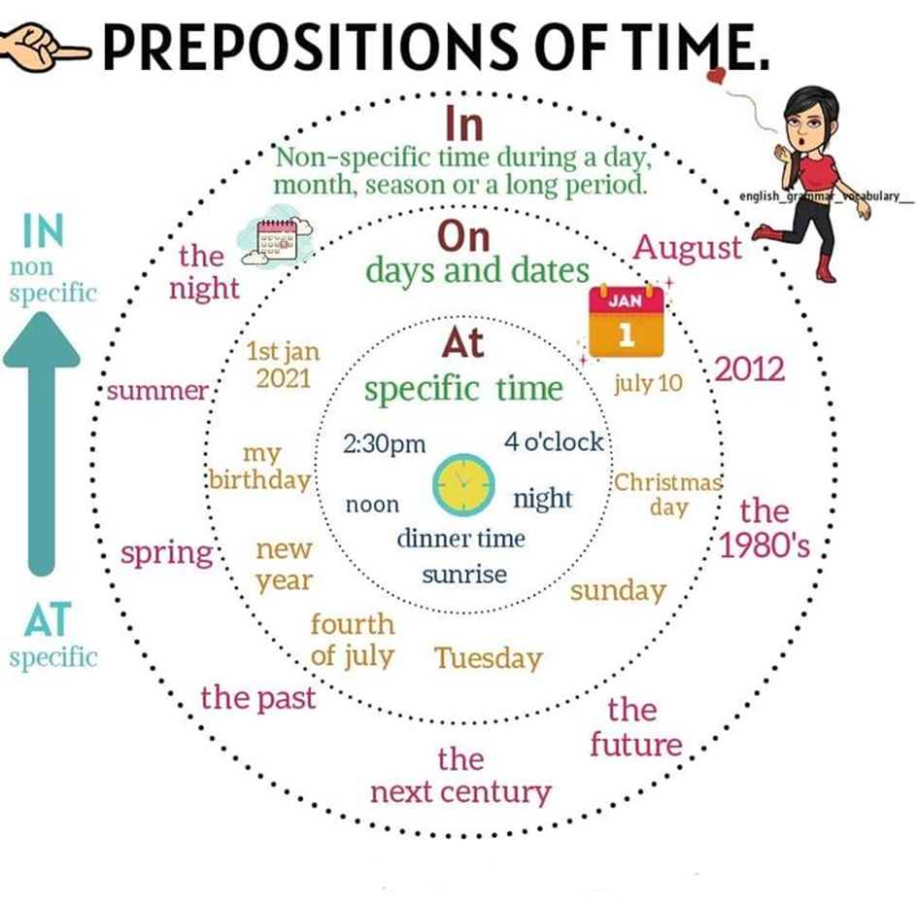

1. **Preposition of place:**

Prepositions of place are used to describe **where** something is located in relation to another object. The most common ones are **in**, **on**, and **at**, along with others like **under**, **behind**, **next to**, etc.

**In**

* Refers to being **inside** a space or enclosed area.

**Examples:**

* The book is **in the bag**.
* She lives **in New York City**.
* The children are playing **in the garden**.

**Key Notes:**

* Use for:
  + Enclosed spaces: *in the room, in the box*.
  + Countries, cities, or regions: *in Spain, in Asia*.

**On**

* Refers to being **on a surface** or **attached to something**.

**Examples:**

* The keys are **on the table**.
* There’s a picture **on the wall**.
* The phone is **on the bed**.

**Key Notes:**

* Use for:
  + Surfaces: *on the floor, on the desk*.
  + Public transport: *on the bus, on the train*

**At**

* Refers to a **specific point or location**.

**Examples:**

* She’s **at the door**.
* He’s waiting **at the bus stop**.
* We met **at the restaurant**.

**Key Notes:**

* Use for:
  + Specific points: *at the corner, at the front*.
  + Events or buildings: *at the airport, at the party*.

**Other prepositions**

* **Under**: Below something.
  + *The shoes are* ***under the bed****.*
* **Over**: Above something, not touching it.
  + *The lamp is hanging* ***over the table****.*
* **Next to / Beside**: Close to or by the side of something.
  + *She’s sitting* ***next to me****.*
* **Behind**: At the back of something.
  + *The car is parked* ***behind the building****.*
* **In front of**: Opposite or facing something.
  + *He’s standing* ***in front of the mirror****.*
* **Between**: In the space separating two things.
  + *The park is* ***between the school and the library****.*
* **Inside / Outside**: Within or beyond a space.
  + *They are* ***inside the house****.*
  + *He’s waiting* ***outside the shop****.*

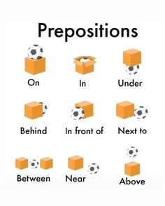

1. **Preposition of direction:**

Prepositions of direction indicate **movement from one place to another**. They describe the path or destination of movement and answer the question "**Where to?**"

**To: Shows movement toward a specific destination.**

* Examples:
  + She went **to** the park.
  + They are traveling **to** Italy.

**Into: Refers to movement from the outside to the inside of something.**

* Examples:
  + He walked **into** the room.
  + The dog jumped **into** the pool.

**Onto: Indicates movement toward a surface.**

* Examples:
  + The cat jumped **onto** the table.
  + She climbed **onto** the roof.

**Toward: Refers to movement in the direction of something, but not necessarily reaching it.**

* Examples:
  + He ran **toward** the building.
  + The car moved **toward** the north.

**Other Prepositions**

**Out of: Movement from the inside to the outside.**

* Examples:
  + She ran **out of** the house.
  + He took the book **out of** his bag.

**Over: Movement above or across something without touching it.**

* Examples:
  + The plane flew **over** the city.
  + He jumped **over** the fence.

**Onto vs. Over:**

* **Onto**: Indicates touching the surface (*The ball rolled* ***onto*** *the floor*).
* **Over**: Indicates passing above without touching (*The ball flew* ***over*** *the fence*).

**Along: Movement in a linear path.**

* Examples:
  + They walked **along** the beach.
  + The car drove **along** the road.

**Across: Movement from one side to the other.**

* Examples:
  + He swam **across** the river.
  + We walked **across** the bridge.

**Through: Movement within a space, often enclosed.**

* Examples:
  + They walked **through** the tunnel.
  + The light came **through** the window.

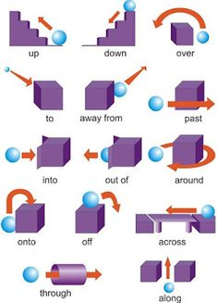

1. **Preposition of cause:**

Prepositions of cause show the **reason**, **motivation**, or **cause** behind an action or situation. These prepositions explain **why** something happens.

**Because of: Indicates the reason for something.**

* Examples:
  + The match was canceled **because of** the rain.
  + She succeeded **because of** her hard work.

**Due to: Similar to "because of," often used in formal contexts.**

* Examples:
  + The delay was **due to** bad weather.
  + The event was postponed **due to** technical issues.

**Owing to: Similar to "due to," used in formal contexts.**

* Examples:
  + The flight was canceled **owing to** heavy fog.
  + He missed the meeting **owing to** illness.

**For: Indicates purpose or a reason for something.**

* Examples:
  + This gift is **for** you.
  + He was punished **for** his behavior.

**Other Prepositions :**

**From: Indicates a source or reason for something.**

* Examples:
  + She suffered **from** exhaustion.
  + His confidence comes **from** years of experience.

**Over: Refers to the cause of an argument or dispute.**

* Examples:
  + They argued **over** the budget.
  + There was a fight **over** the last slice of pizza.

**Through: Indicates the means or cause of an action or state.**

* Examples:
  + She succeeded **through** hard work.
  + He lost his job **through** no fault of his own.

**By: Indicates the agent or reason.**

* Examples:
  + He succeeded **by** sheer determination.
  + The house was damaged **by** the storm.

1. **Preposition of manner:**

Prepositions of manner describe **how** something happens or the method by which an action is performed. They often answer the question **"In what way?"** or **"How?"**.

**By: Indicates the method or means used to do something.**

* Examples:
  + She traveled **by** car.
  + The letter was sent **by** mail.
  + He won **by** working hard.

**With: Refers to the instrument, tool, or quality used to perform an action.**

* Examples:
  + He cut the paper **with** scissors.
  + She painted the picture **with** great care.

**In: Describes the manner or style in which something is done.**

* Examples:
  + They acted **in** a hurry.
  + She spoke **in** a loud voice.

1. **Preposition of possession:**

Prepositions of possession describe a **relationship of ownership or belonging** between one thing and another. They show **who or what something belongs to**.

**Of: Indicates a belonging or relationship.**

* Examples:
  + The roof **of** the house is red.
  + She is a friend **of** my brother.

**To: Indicates a connection or relationship.**

* Examples:
  + This book belongs **to** me.
  + The key **to** the door is missing.

**With: Indicates possession in terms of characteristics or attributes.**

* Examples:
  + The man **with** the black hat is my uncle.
  + A house **with** a big garden is ideal.

**About: Indicates association or relation, often to show a connection to a subject or matter.**

* Examples:
  + This is a story **about** her life.
  + The book **about** animals is interesting

**Other Prepositions:**

**By: Indicates the creator or possessor, often used for authorship.**

* Examples:
  + This painting is **by** Picasso.
  + The novel **by** her was a bestseller.

**For: Indicates intended possession or purpose.**

* Examples:
  + This gift is **for** you.
  + The tools are **for** building the shed.

**From: Indicates origin or source of ownership.**

* Examples:
  + This letter is **from** my friend.
  + I received a gift **from** him.